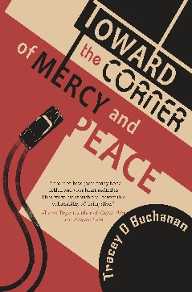
www.TraceyBuchanan.com

Discussion Questions

- Why do you think Minerva buries herself in stories of the dead rather than connecting with real people?

- How do you think the people of Minerva’s community perceive her, and did your opinion about her change over the course of the book?

- Do you think Minerva is losing touch with reality, is imaginative, lonely, or a combination?

- Why do you think Robert persisted in trying to develop a relationship with Minerva? Do you think you’d like to have her as a friend?

- What is the significance of Minerva’s “visitors” being no longer alive? Discuss what each visitor revealed about Minerva and how the cemetery histories that Minerva writes illuminate her character and advance the story.

- Settings are critical to this novel as well as to the character development of Minerva, from the church to the cemetery to the city of Paducah itself. Discuss.

- Discuss the meaning of the title as it relates to the characters in the story.

- What are the primary themes of the book and how does the author develop them?

- Minerva allows herself one indulgence: her car. What does this choice reveal about her?

- This is an historical novel, but unlike many other such novels, which place key national or international events at their centers, this novel focuses on personal histories. Why do personal histories matter? How do they illuminate the past for us?

- How does love transform Minerva?

- This is a tragi-comedy. What made you laugh? What made you feel sadness?

- What advice would you give Minerva about life? Do you know anyone like her?

- Both grief and love connect people in this novel. Discuss.

- What do you think is next for Minerva?

Toward the Corner of Mercy and Peace (June 20, 2023, Regal House Publishing) is available through Regal House Publishing, Amazon, Bookshop, and Barnes & Noble.

To schedule an event or for media inquiries, please contact Caitlin Hamilton Summie at Caitlin Hamilton Marketing & Publicity, LLC, caitlin@caitlinhamiltonmarketing.com

