Random Bio Bits (Just in Case You Wondered)

- I’m 6’ tall. I was measured in my doctor’s office as 5’11. I did request they remeasure me three times and all three times it was the same. But you can’t believe those doctors. Not their measuring tapes OR their scales.
- I’ve flown in a hot air balloon twice (different states, different balloons, different pilots if that matters to you. I’d go again.).
- My top ten favorite songs, in no particular order are: 100 Years by Five for Fighting, Bridge Over Troubled Water by Simon and Garfunkel, Is He Worthy by Chris Tomlin (words by Andrew Peterson), Thunder by Imagine Dragon (I don’t know the words, I just like the way it sounds. I hope the lyrics are okay. I don’t feel like googling them to find out), Wonder by Natalie Merchant, something by ELO…something by the Beach Boys…Linda Ronstadt…And what about all those great hymns? Okay, never mind. You’re going to have to be satisfied with my top five. This is too hard.
- Some of my all-time favorite books, in no particular order, are: A Tree Grows in Brooklyn by Betty Smith, To Kill a Mockingbird by Harper Lee, Peace Like a River by Leif Enger, Ordinary Grace and This Tender Land both by William Kent Krueger, All the Light We Cannot See by Anthony Doerr, The Book Thief by Markus Zusak, The Nightingale by Kristin Hannah, Pachinko by Min Jin Lee, A Man Called Ove by Frederik Backman, Olive Kitteridge by Elizabeth Strout, Bel Canto by Ann Patchett, and The Hundred-Year-Old Man Who Climbed Out the Window and Disappeared by Jonas Jonasson, The Poisonwood Bible by Barbara Kingsolver… I could go on ad nauseum. But I won’t.
- I’m a mixture of English, Irish, Danish, and Native American (Cherokee).
- I cannot yodel and don’t whistle very well.
- I attended a professional whistler’s performance when I was in the seventh grade. It was one of only two school assemblies I remember. He was amazing. (The other assembly I remember was part of a ballet, which was also quite impressive, but I remember it more because of the boy I was sitting with.)
- I took karate, skeet shooting, square-dancing, and sailing for my P.E. credits in college. Today, I would fall over if I tried to front kick, can’t hit the broad side of a barn when shooting, am the person who messes up everyone in the do-si-do, and would capsize any sailboat post-haste. But I’ve got to give those college professors kudos. They gave it their best shot.
- I can’t tell a joke.
- I once had a broken neck. (I know! That’s not funny.)
- I met Art Linkletter at the Paducah airport (yes, we have an airport) just hours before giving birth to our firstborn.

For media and events contact:
Caitlin Hamilton Summie
Caitlin Hamilton Marketing & Publicity, LLC
caitlin@caitlinhamiltonmarketing.com

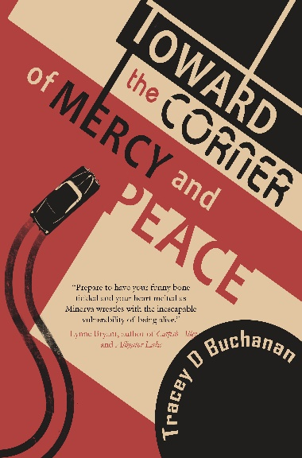

Frequently-Asked Questions

- How long did it take you to write Toward the Corner of Mercy and Peace?
- Is Minerva based on anyone?
- Where did you do your research and do you like researching?
- How do you pronounce that town where you’re from and where is it?
- Why did your mother spell your name with an E?
- Will there be a sequel to Toward the Corner of Mercy and Peace?
- Did you spend much time at Oak Grove Cemetery and have you fallen in any graves?
- How did you get the idea for Toward the Corner of Mercy and Peace?
- What’s your dog’s name?
- Were you really a twirler in high school?

Sorry, but you’ll have to invite me to your book club for me to answer those questions. And please do! If it’s possible for me to attend in person, I will. If not, I’m happy to meet via Zoom.

For media and events contact:
Caitlin Hamilton Summie
Caitlin Hamilton Marketing & Publicity, LLC
caitlin@caitlinhamiltonmarketing.com

